|  |  |
| --- | --- |
| **Recibo de venda do Anjo do Heber**  **Terceiro Festival Agrosserra**  **da pracinha de Secretário**  **R$3.200,00** |  |

**Extrato por período**

**Extrato**

|  |  |  |  |  |  |  |
| --- | --- | --- | --- | --- | --- | --- |
| **DATA MOV.** | **NR. DOC.** | | **HISTÓRICO** | | **VALOR** |  |
| 24/07/2017 | | [192045](javascript:abreLink('192045',%20'24/07/2017');) | | [DOC ELET](javascript:abreLink('192045',%20'24/07/2017');) | **3.200,00 C** |  |

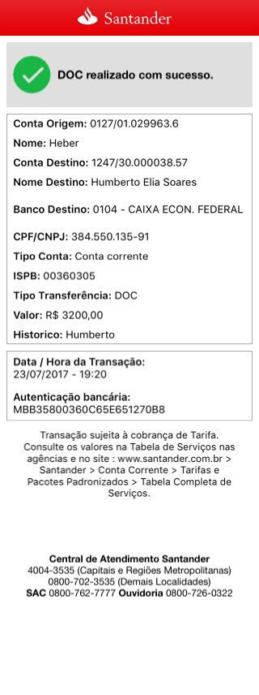

|  |  |  |  |  |  |  |
| --- | --- | --- | --- | --- | --- | --- |
| **DATA MOV.** | **NR. DOC.** | | **HISTÓRICO** | | **VALOR** | **SALDO** |
| 21/07/2017 | | 211053 | | COMPRA ELO | **6,90 D** | **87,83 C** |
| 21/07/2017 | | 211411 | | COMPRA ELO | **4,48 D** | **83,35 C** |
| 24/07/2017 | | [192045](javascript:abreLink('192045',%20'24/07/2017');) | | [DOC ELET](javascript:abreLink('192045',%20'24/07/2017');) | **3.200,00 C** | **3.283,35 C** |
| 24/07/2017 | | 220748 | | COMPRA ELO | **9,00 D** | **3.274,35 C** |
| 24/07/2017 | | 220758 | | COMPRA ELO | **9,50 D** | **3.264,85 C** |
| 24/07/2017 | | 240753 | | COMPRA ELO | **9,00 D** | **3.255,85 C** |
| 24/07/2017 | | 241135 | | COMPRA ELO | **3,92 D** | **3.251,93 C** |
| 24/07/2017 | | 241139 | | COMPRA ELO | **48,50 D** | **3.203,43 C** |
| 24/07/2017 | | 241402 | | COMPRA ELO | **3,00 D** | **3.200,43 C** |
| 25/07/2017 | | [027912](javascript:pesquisaDOC('25/07/2017');) | | [DOC ELET E](javascript:pesquisaDOC('25/07/2017');) | **500,00 D** | **2.700,43 C** |